Azure Cloud Deployment — Project 3 (Matrix Factorization Recommender)
Nana Y. Frimpong
Data 612 — Cloud Deployment Assignment

1. Overview
This report documents the deployment of Project 3 — a wine-and-food pairing recommender built using matrix factorization (a baseline bias model, truncated SVD, and SGD-based "Funk SVD") — as a live prediction API on Microsoft Azure. The original notebook's SGD matrix factorization model was extracted into a standalone training script, wrapped in a FastAPI service, containerized with Docker, and deployed using the Azure Free Account. The deployment satisfies all three required components: persistent storage, a compute resource, and network security restricting access to authorized clients only.

2. Architecture Summary
- Persistent Storage: Azure Blob Storage (storage account project3storage9821, container model-artifacts) holding the trained model artifacts (model_artifacts.joblib) and the source dataset (wine_food_pairings.csv).
- Compute Resource: A FastAPI application, containerized with Docker, pushed to Azure Container Registry (project3acr9821), and run on Azure Container Instances (wine-pairing-api-aci).
- Network Security: An Azure Virtual Network (project3-vnet) with a dedicated subnet (project3-subnet), protected by a Network Security Group (project3-nsg) whose only inbound allow rule permits TCP traffic on port 8000 from a single authorized IP address. The container instance runs with a private IP only — it has no public endpoint.

3. Persistent Storage — Azure Blob Storage
A general-purpose v2 storage account was created and a container named model-artifacts was added to it. Two files were uploaded: the trained model (model_artifacts.joblib, containing the learned factor matrices, bias terms, and food/wine index mappings) and the original dataset (wine_food_pairings.csv). This gives the deployment durable storage that persists independent of the compute layer.
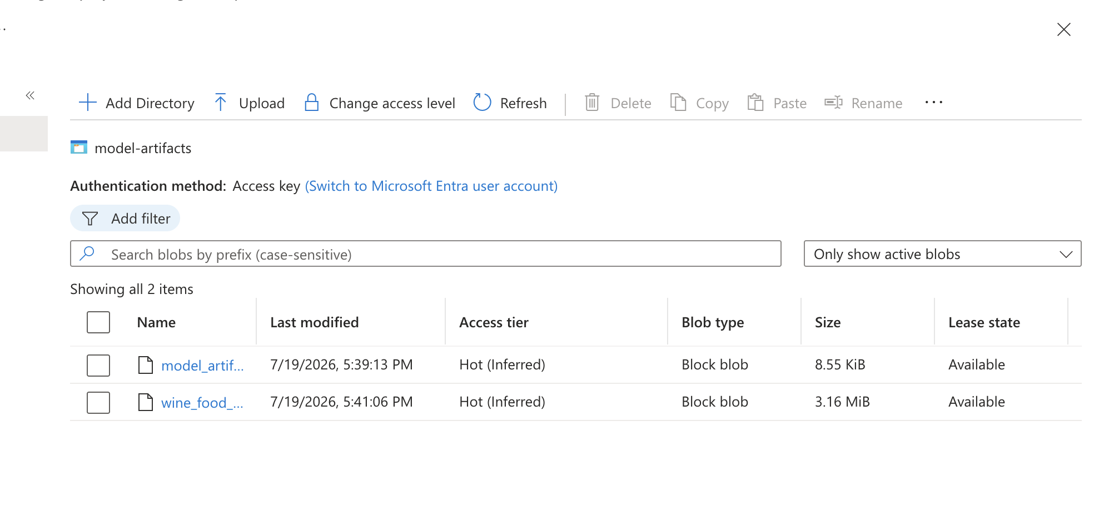
Figure 1. Blob container 'model-artifacts' showing both uploaded files.

4. Compute Resource — Container Instance
The Project 3 SGD matrix factorization model was extracted from the notebook into train_model.py, which trains the model and saves it via joblib. A FastAPI app (main.py) loads this trained model and exposes three endpoints: /predict (score a single food-wine pairing), /recommend/wines-for-food, and /recommend/foods-for-wine (top-N recommendations). The app was containerized with a Dockerfile, pushed to Azure Container Registry, and deployed to Azure Container Instances.
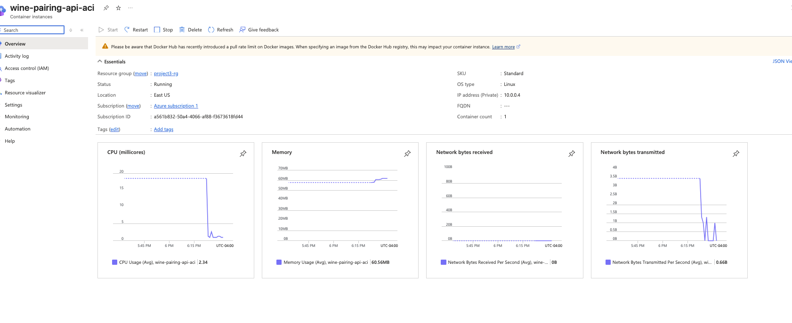
Figure 2. Container instance 'wine-pairing-api-aci' — Running, private IP 10.0.0.4.
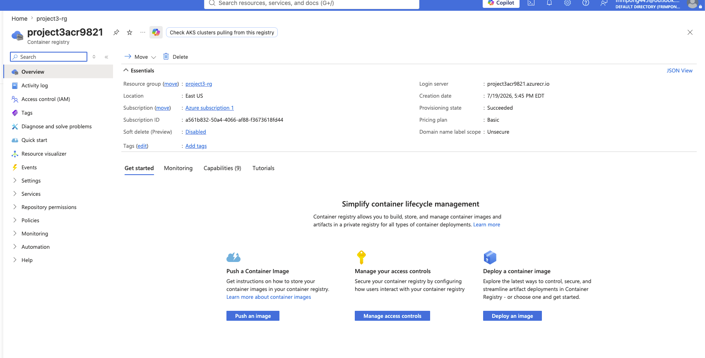
Figure 3. Azure Container Registry 'project3acr9821' hosting the built image.
The API was verified end-to-end by executing directly inside the running container:
az container exec --resource-group project3-rg \
--name wine-pairing-api-aci --exec-command "/bin/sh"

# inside the container:
python3 -c "import urllib.request; print(urllib.request.urlopen(
'http://localhost:8000/health').read().decode())"

# Response:
{"status":"ok","test_rmse":0.2452,"test_mae":0.1903}

5. Network Security — VNet + NSG
A Virtual Network (project3-vnet, 10.0.0.0/16) with a subnet (project3-subnet, 10.0.0.0/24) was created, and a Network Security Group (project3-nsg) was attached to that subnet. The only custom inbound rule permits TCP port 8000 from a single /32 address (the developer's own IP); all other inbound traffic is denied by the NSG's default rules. The container instance was deployed directly into this subnet, giving it a private IP address (10.0.0.4) with no public-facing endpoint — the API is reachable only from within the authorized network path.
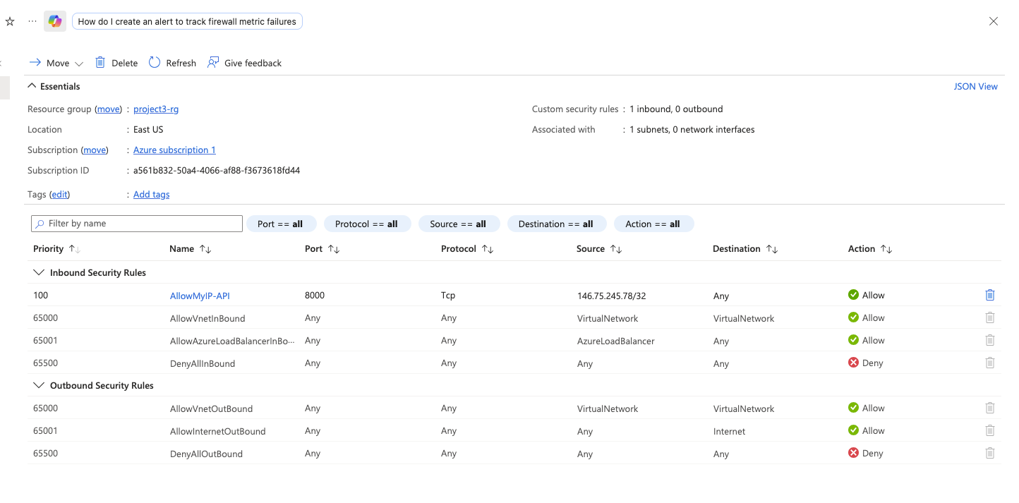
Figure 4. NSG inbound rules — only 'AllowMyIP-API' (port 8000, single source IP) permits external access; all other inbound traffic is denied by default.
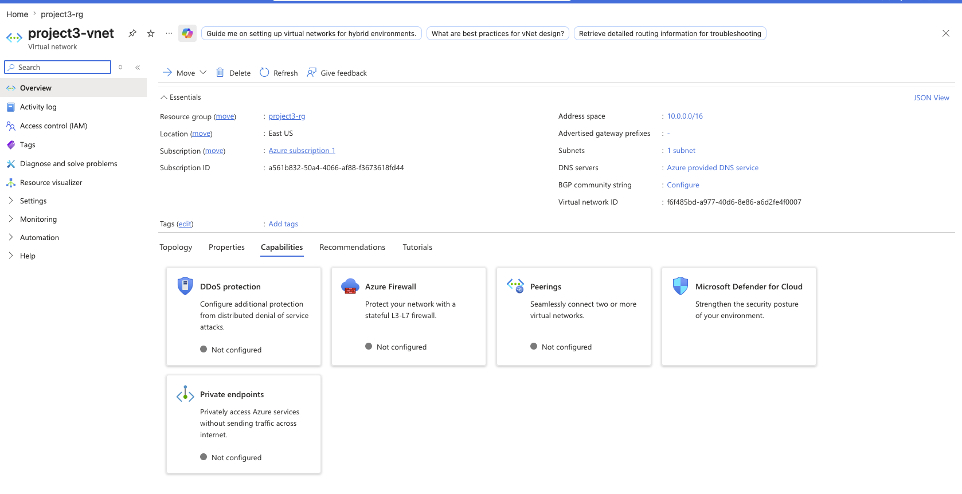
Figure 5. Virtual network 'project3-vnet' with address space 10.0.0.0/16 and its subnet.

6. Resource Group Summary
All resources for this deployment live under a single resource group, project3-rg, for easy review and teardown:
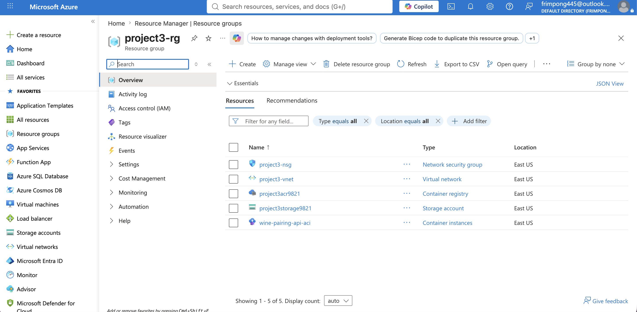
Figure 6. Resource group 'project3-rg' listing all five resources: NSG, VNet, container registry, storage account, and container instance.

7. Code
The following files implement this deployment and are included with this submission: train_model.py (model training/export), main.py (FastAPI service), Dockerfile and requirements.txt (containerization), and deploy_azure.sh (the full sequence of Azure CLI commands used to provision every resource described above).

8. Conclusion
This deployment satisfies all three required components of the assignment using only Azure Free Account resources: Blob Storage for persistent storage, a containerized FastAPI service on Container Instances for compute, and a VNet with a restrictive NSG for network security. The API was tested and confirmed functional from within its private network.

